Original Request 1

First Draft 1

Data Sources Used 2

Notes 3

## Original Request

General Description:

We are looking to develop practice level (each practice has their own report) that visually displays the number of patients they have referred to the study over time as compared to the practice average. The goal for completion and dissemination of these reports is early March 2023. We are envisioning that this would involve collaboration between someone on the data team (Sabrina?) and Kim Wiggins, who will have these numbers from the weekly reports she runs (new numbers should not be calculated without Kim). It would be helpful to have a report mock up for Sean and Tamara to review and provide feedback on in January (does not need to be “real data”). Below is a list of data points that the brainstorming group brought up to include but we have time to get creative with this!

Data points to consider:

* Patients referred by each practice with some display of this rate over time  
  use these charts from Kim’s weekly reports as example/inspiration. We’d keep the red line (patients identified by practices) and replace the other one with that particular practice’s referral trajectory.

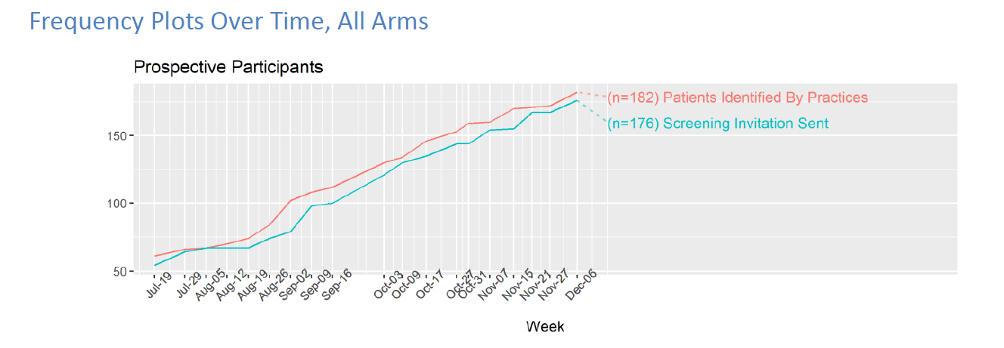

* + What happened to the patients
    - For virtual practices: engaged with virCIS, completed, didn’t participate, etc.
    - For TIPS,TIPS w/ PF: consented/enrolled, reached max contact, declined, etc.
* Average number of patients referred across all practices
* Average number of patients referred from practices in the same arm (TIPS, TIPS w/ PF, Virtual)
* Count of Spanish speaking and English speaking patients
* Other things you think the practices might be interested in/motivated by

## Notes

* Showing change over time didn’t work for most practices; either a) they had one upload and there’s only one point (ex: practice splitid 17, all 17 patients uploaded in June – would be one dot, not a line) and/or b) the scale is so markedly different than the intervention total that it just doesn’t look right; the highest referral is 18, but a majority of individual practices have fewer than 10. (image below)

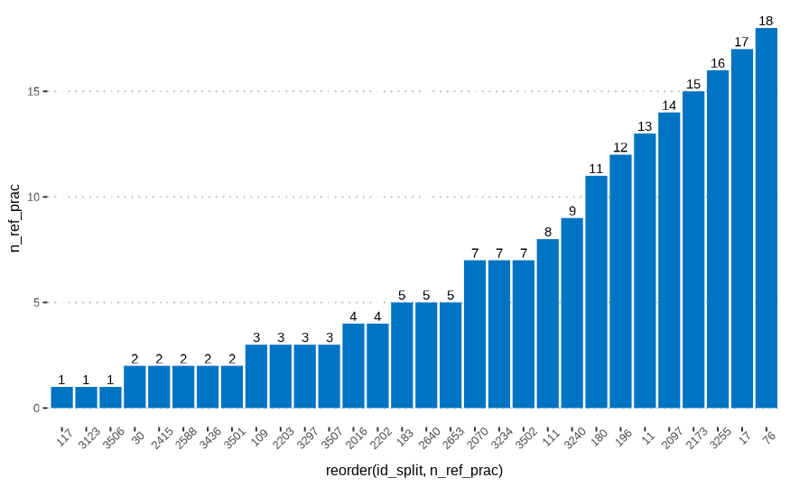

## Data Sources, Definitions

Files, Project / Report IDs: Data Sources & saved datafiles

* Practice Info, Referred Patients
  + PROJECT Patient Recruitment Database [ID 24705];
  + REPORT Patient IDs for Individual Prac Report (KW) [ID 88650]
  + SAVED as lineline_pr.csv
* Patient Benchmarks:
  + PROJECT Patient Assessment Database [ID 23698]
  + REPORT 81709
  + Saved as linelist_pt.csv

## Updated Content Specifications

Email from Tristen, 02/14

Of the XX *patients* your practice has referred to the study, XX *have* enrolled (XX%), the study team is in the process of recruiting XX (XX%), and XX *are* not participating (XX%). For referred patients who are not participating, we’ve documented the following reasons: Declined to Participate (n=5), Duplicate or Invalid Referrals (n=1), and Other (n=2)

*INTERNAL NOTES:*

* *“referred to the study*”: # patients the practice has submitted to the PPR
* *“enrolled”:* # patients who have completed the consent form   
  ([consent_sig]<>”” OR [scanned_consent_ucd]<>””)
  + KW Question: And patientend_dtd == “”? Include patients not participating?
* *“in the* *process of recruiting”:* Referred but not enrolled or end dated
* “*not participating*”: # patients who have an end date

## Data Sources, Procedures

### Linelists: All Referred

Linelists for practices and patients extracted from API / REDCap, refactored, and saved in dir

1. Recruitment Database, report ID 88650
2. Linelists saved and added to Teams folder: CGM/General/Files/Data/Practice_Reports/202302/data

Table linelist_pr, 2023-02-25 [33: 3]

|  |  |  |  |
| --- | --- | --- | --- |
| original var, if from report | variable | settings | notes |
| splitid | id_split |  | primary key, parameter |
| interventionarm_final | cd_arm | where not NA | add factor levels, labels |
| clinicname_preferred | prac_name |  |  |

Table linelist_pt, 2023—2025 [269 : 6]; joined linelist_pr for practice info

|  |  |  |  |
| --- | --- | --- | --- |
| original var, if from report | variable | settings | notes |
| splitid | id_split |  | primary key, parameter |
| patientid_calc | id_patient | where not NA |  |
| patientassessment_dtd | ind_in_ptdb | NA = 0, non NA= 1 | for debugging |
|  | cd_arm | … | from join linelist_pr |
|  | prac_name | … | from join linelist_pr |
|  | fct_arm | 1 = “TIPS”, 2 = “TIPS+PF”  3 = “virCIS” |  |

### Referral Metrics

* Generated from linelists (linelist_pr, linelist_pt), parameterized on id_split
* Used in top portion and bar chart
* Only includes practice name for the practice reporting on; others are anonymized

|  |  |  |  |
| --- | --- | --- | --- |
| metric | var_name | source | notes |
| total referred pts, study | n_cgm_ref | linelist_pt | 2/25, n = 269 |
| avg pts referred, arm | avg_arm_ref | linelist_pt | ceiling mean |
| total referred pts, practice | n_pr_ref | linelist_pt |  |

### Patient Status Metrics

Patient Assessment Database, Report ID 89536

* Joined to linelist_pt to capture referred patient_id’s not yet added to the patient assessment database
* Subset to practice-specific patient linelist
* Used in inline text (below bar chart) and donut chart
* Saved as ‘pt_benchmarks.csv’ > upload to Teams (last ran 2/25/2023)
* Study-wide metrics, 2/25: ind_end, ind_enroll, & ind_recruit should total n_cgm_referred (269)
  + ind_screen n=119
  + ind_end n = 54
  + ind_enroll n = 86
  + ind_recruit n = 129
    - 54+86+129 = 269

|  |  |  |  |
| --- | --- | --- | --- |
| original var, if from report | variable | settings | notes |
| screening_survey_english_... | ind_screen | changed 2’s to 1, else 0 | & ind_end == 0 |
| patientid | id_patient |  |  |
| patientend_dtd | ind_end | NA changed to 0’s | ind_end == 1 |
| patientend_reason | fct_end_reason |  | language in comments |
| consent_sig | ind_enroll | values not NA and no end date for patient | ind_end == 0 |
| scanned_consent_ucd |
|  | ind_recruit |  |  |
| metric | var_name | source | notes |
| total referred pts, study | n_cgm_ref | linelist_pt | 2/25, n = 269 |
| avg pts referred, arm | avg_arm_ref | linelist_pt | ceiling mean |
| total referred pts, practice | n_pr_ref | linelist_pt |  |

The table below is a comprehensive list of data sources used in generating the reports (REDCap project ID, report ID’s, variable names)

|  |  |  |  |  |  |  |
| --- | --- | --- | --- | --- | --- | --- |
| label  Variable | REDCap  Variable Name | REDCap  ProjID | REDCap  RptID | Data as of:  Date | KW reference  Rename | saved as, dir, etc  Notes |
| Split ID | splitID | 24705 | 88650 | 02/13 | id_split |  |
| Practice Name | clinicname_preferred | 24705 | 88650 | 02/13 | practice_name |  |
| Study Arm | interventionarm_final | 24705 | 88650 | 02/13 | cd_arm, fct_arm |  |
| n pts Identified | patientassessment_dtd | 24705 | 88650 | 02/13 | Calculated |  |
| n pts identified |  | 24705 | 88650 | 02/13 | calculated > id_split |  |
| n pts Identified |  | 24705 | 88650 | 02/13 | Calculated |  |
| avg patients ref’d | interventionarm_final | 24705 | 88650 | 02/13 |  |  |

## Notes